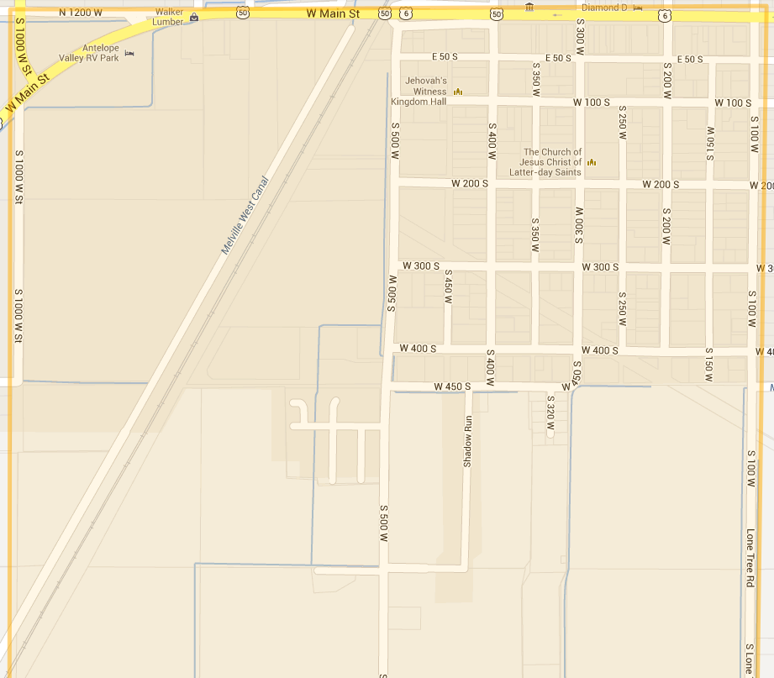
#1 Delta
Special Instructions

Write Spanish Addresses Here

Work only the INSIDE of the boundaries unless map says otherwise.
(South West)
Work until South Boundary which is 1000 South

